Zee Music Company Analysis Requirements
Dashboard Page 1 — Music Performance Overview
- Identify the artist with the highest number of streams.

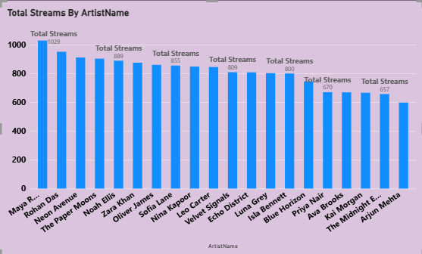
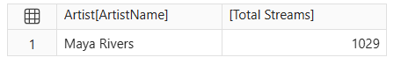

- Display the top 10 artists based on total revenue.
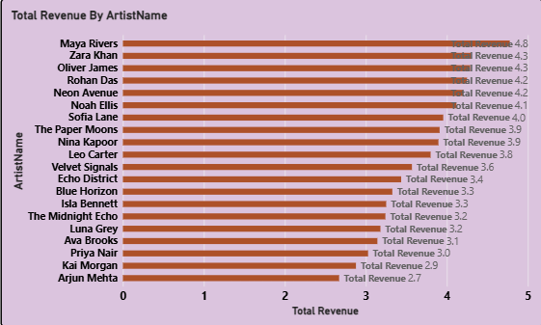
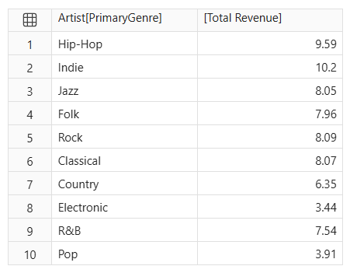
- Compare the revenue generated by different genres.
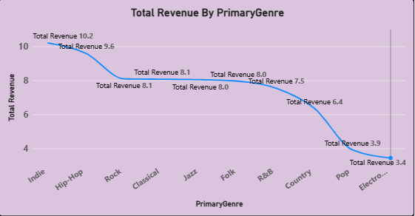

- Identify the album with the highest listening activity.
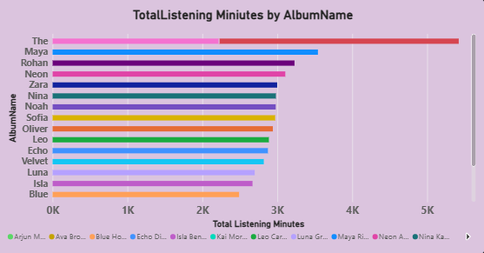


- Analyse monthly stream trends.

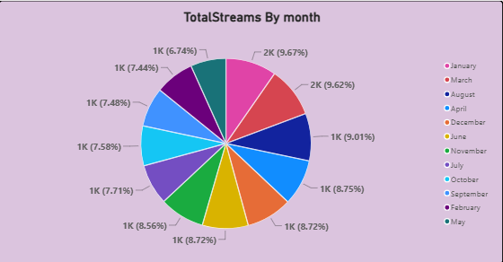
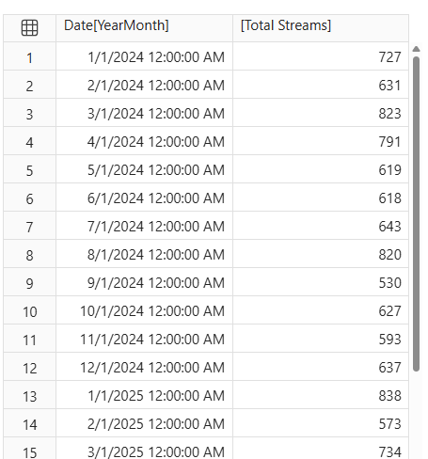
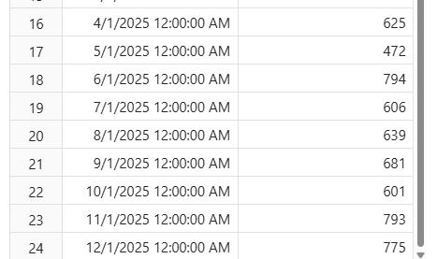
- Compare revenue between 2024 and 2025.
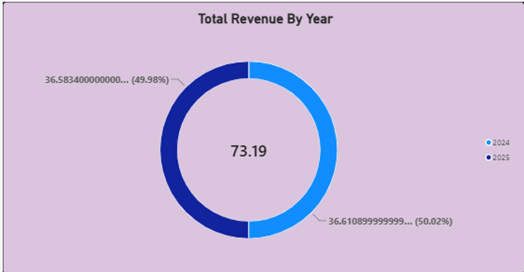
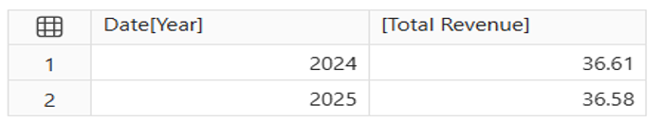

Dashboard Page 2 — Listener Behaviour and Revenue Analysis
- Determine which subscription type generates the highest total revenue.
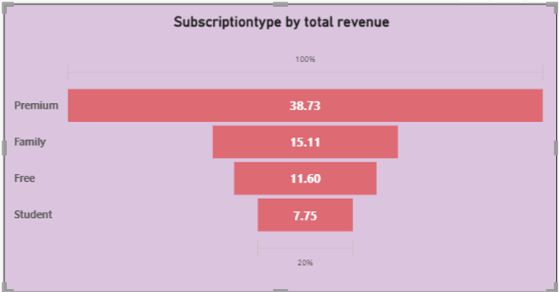
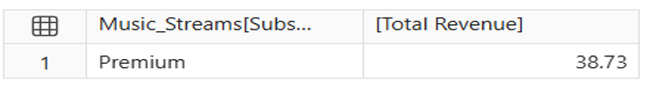
- Compare the average revenue per record for each subscription type.
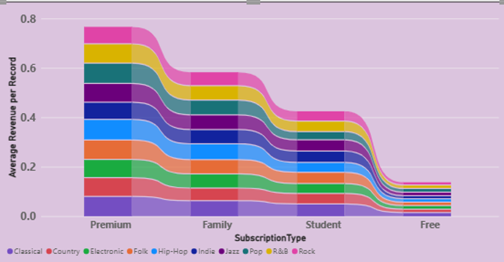
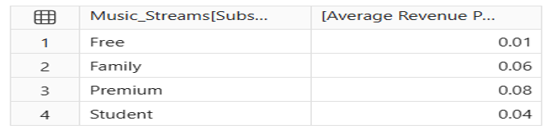

- Identify which device accounts for the most streaming activity.
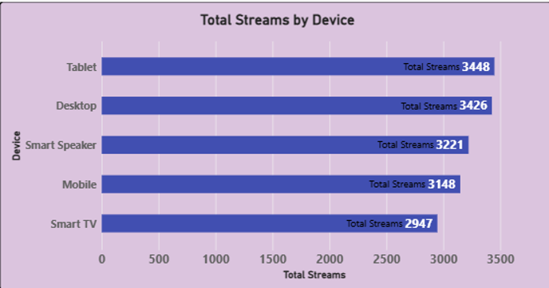
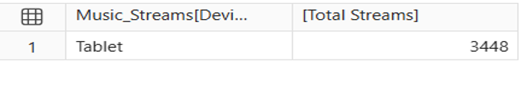

- Compare listening behaviour across countries.
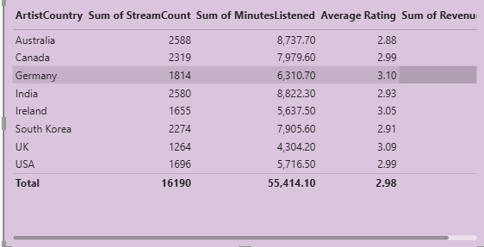
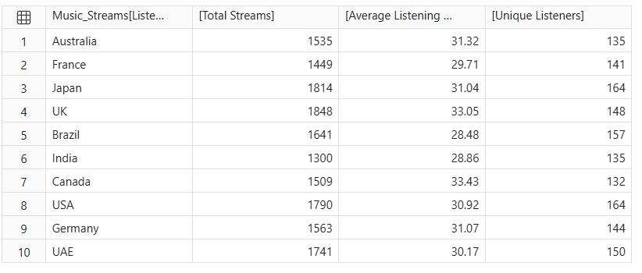
- Find which playlist source has the highest number of streams.
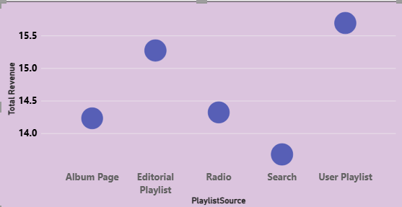
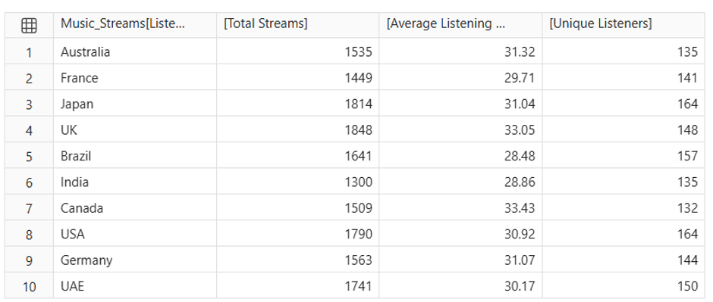

- Compare completed and not-completed records.
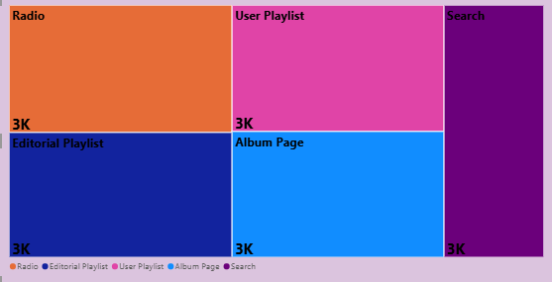
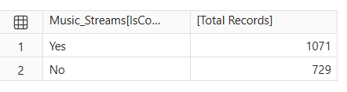

- Analyse the relationship between Skip Count and Rating.
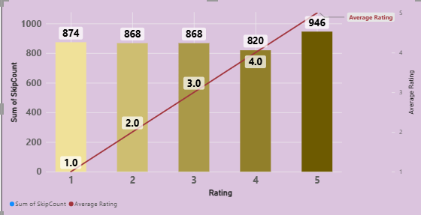
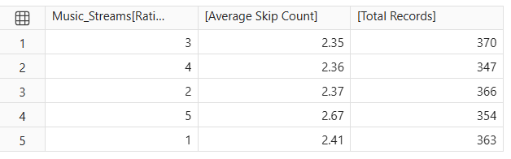

- Compare revenue growth with the previous year.
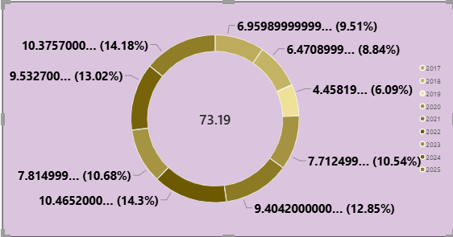
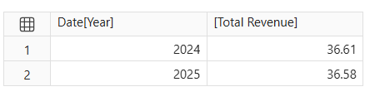

- Identify artists or albums with high streams but relatively low revenue.


